G Rafto’s market takes
4/10/20
Well another wild, wild, week. Here we sit on Good Friday, we have a lot of things to be thankful for, the market being closed today is one of them.
Market hot points
- Plant closure
  - Single biggest topic of the market
  - Fear has been here for weeks
  - Is it sell the rumor, buy the fact
- PPP and other stimulus
  - 16 bil possibly coming to ag.
  - All of this will help a bunch.
- Sheep slaughter
  - Down 39% wow. That is the product that will back up. That market was on fire before this happened. Restraunt demand being shot in the nuts, hurts lamb consumption badly. If people cant cook a steak, they damn sure can’t cook a lamb chop.
- President’s Address
  - Tough decision to be made in 2 weeks to open or not reopen
  - People die at home also
  - Social distance helps
  - Economy needs to get going
  - He is going after WHO next week
  - China may be talking to Venezuela, which if true, would really make Pres. Trump mad.

If there was any risk management play available to use at all, it is green grass and time.

As far as lamb slaughter goes, Thursday is the big day. At the first of the year we were killing 9k on Thursday. Then dropped to 8, now to 7. 29 estimated total for this week.

Lamb weights spiked the last month of march. Huge gains. Already showing the effects of carrying lambs due to smaller slaughter. We hope this slaughter level doesn’t hurt beef. We hope we are current enough. Nobody knows.

Open interest has a whole has been down. June has a lot compared to the other months. There aren’t any in the other months hardly. April is that blue line. I think that is the craziest liquidation line I’ve seen.

Basis in the feeder cattle has been wild. The swings are unbelievable. Basis is the most important thing to our equity as cattle producers. For a hedged up producer this is a huge financial gain. For some one that stays open cash, it hurts. There weren’t as many hedged producers during this rout as we all wish there were. I still think risk lies in cash. Weak basis will benefit the futures, and shrink basis. Taking away that avenue of profitability as well possibly

Closing thoughts-
The market is made up in time frames. The risk is applied to those cattle in certain time frames. The riskiest and most vulnerable cattle to this bad market are the 60-90 day cattle. Cattle that you can get beyond that time frame look to have a chance at breakeven or better. Some believe the fall will be the highest markets, crazier things have happened. Bottom line, try to put pounds on the cattle, as cost efficient as possible. If you are not marketing in the next 60-90 days, then be alert to the market, but the time to price fall calves might be yet to come.

The next chart reflects total producer shorts. This is at technically a five year low, but we can still go lower. Meaning we still have basis traders out there. Does the basis stay strong and reward them?

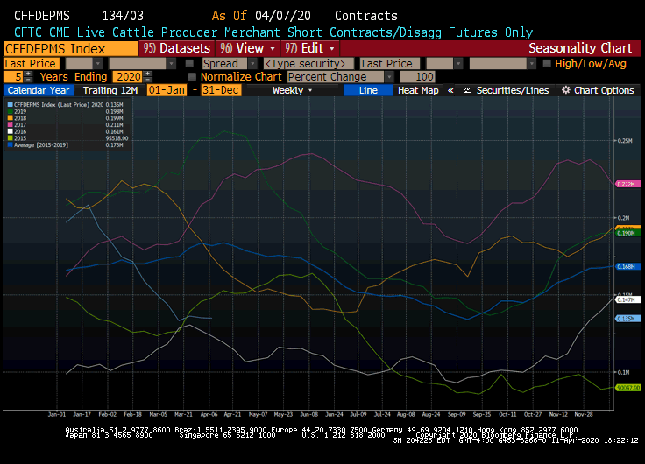

Below is the weather for Craig, CO. As you can see we get real cold on Monday. This is going to be kind of the norm for all of western CO. It takes us until 4/23 to get back to the warmer temperature we are seeing today.(4/10/20). The trend looks to be warmer and drier in week 2. (see 2nd and 3rd image down)

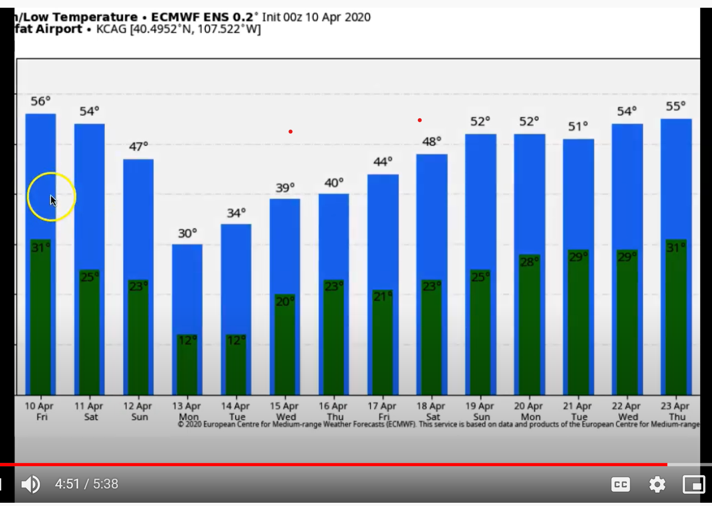

11-15 day precip

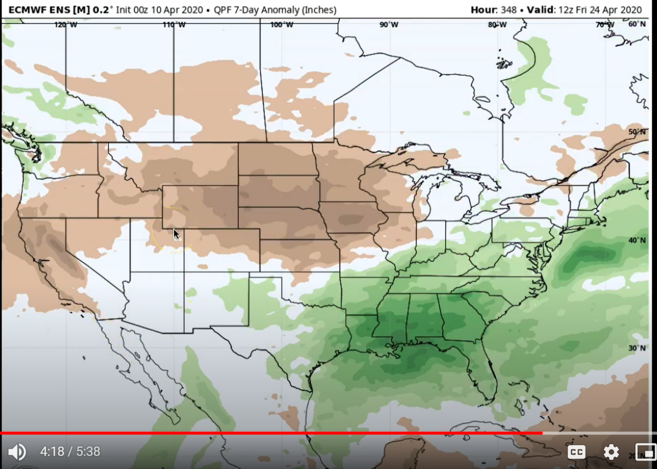

11-15 day temp
