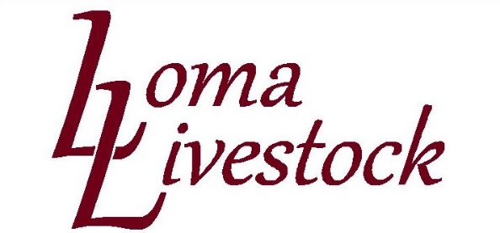
Feeder Cattle
4 blk strs 837 lbs $126.75/cwt Terril Johnston Moab, UT
4 blk strs 918 lb $125/cwt Robert Cerise, Carbondale, CO
2 blk strs 967 lbs $124/cwt Robert Cerise, Carbondale, CO
5 mxbk hfrs 878 lbs $127/cwt Replacement Dillion and Samantha Kujala. Burns, CO
2 rwf heifers 915 lbs $126/cwt Replacement Dillion and Samantha Kujala. Burns, CO

Pairs
7 Hd blk 1st calf hfr pairs. Queen of Diamonds, $2200/hd Diamond Peak Cattle CO. Craig CO
4 hd bwf 1st calf hfr pairs, J Spears, $2150/hd Diamond Peak Cattle CO. Craig CO
3 bwf Solid mouth pairs. $1300/hd

Weigh Cows
High yielding Cutter: $64-$65/cwt
Med Yielding: $61-$62/cwt
Lower Yielding: $53-$57/cwt

Slaughter Bulls
1 Char bull, 2235 lbs., $96.50 Campell Hansmire Sheep LLC. Mack, CO
1 blk bull. 1990 lbs., $96/cwt Sampinos Livestock. Price, UT
1 Char bull, 2015 lbs., $95.50/cwt Campell Hansmire Sheep LLC. Mack, CO
1 blk bull, 2110., $94/cwt Sampinos Livestock. Price, UT

